SSIP PROPOSAL FORMAT
Title of the proposal |  | X- CAM (Controlled Autonomous Monitoring)
Details of Innovator: |  | Name Dhyumaan Raval  E-mail dhyumaanraval007@gmail.com  Mobile number +91 9624700633  Semester III (EC)  Name Meet Jain  E-mail meetjain538@gmail.com  Mobile number +91 9998760465  Semester III (EC)
Details of Mentor: |  | Name : Prof. Shital Thakkar  Email ID : shitalthakkar.ec@ddu.ac.in  Contact no : +91 9925025307
Number of Team members |  | 2
Duration of the project |  | 6 months
(A) Basic Information Related to Project :-
Project X-CAM aims to develop cutting-edge tech that can autonomously surveil a designated area and provide live video feeds and data. X also aims to address flight time limitations by incorporating a smart charging pad system that allows the drone to recharge autonomously, extending its operational capabilities. This project seeks to combine advanced drone technology, artificial intelligence, and computer vision to create a highly efficient and reliable autonomous surveillance solution.
(B) Description of Problem :-
In J&K , 3 army officials died by falling into a deep gorge during patrolling.
Officers have to do patrolling by physically going to the sites by themselves. This traditional method consumes a lot of time, fuel and man power, and sometimes their lives too.
In a latest accident, a speeding truck had rammed into a police patrolling vehicle, injuring senior police inspector of Beltarodi police station, Vijay Talware, along with two cops.
Many such accidents happen during patrolling, which must be avoided.
Adding to that, every year tons of fuel is consumed in patrolling. Approximately 15 lakh gallons of petrol is used by UP police alone, which is estimated to be Rs 57,91,68,002.
The traditional patrolling done by the officials is based on a reactive model where police officers respond to incidents after they occur. This approach can lead to a focus on crime response rather than crime prevention. It may not effectively address the underlying causes of crime or proactively deter criminal activity. In large scale events too, security is the topmost priority for the government and many times security is compromised because of less amount of resources or less manpower.
Even when a state is hit by a natural disaster a huge amount of manpower is required for search and rescue operations. These traditional search and rescue methods are very tedious and ineffective and can provide a limited coverage of the affected areas. Although manual control seems best, but it has lot of drawbacks to cover.
The disaster also exposes the rescue personnel to significant risks and hazards. They may face physical dangers such as unstable structures, debris or hazardous material as well as psychological stress and trauma. These risks can impact the effectiveness and safety of the rescue operation.The traditional methods also rely on incomplete information especially in the early stages of the operation.
In industries, hazardous environments are a huge risk to the human workers.They also need large teams of personnel, specialized equipment and infrastructure for certain tasks hence making the process of data collection, inspections, surveying ultimately increasing the time for carrying these tasks.
The global drone market today offers the self charging pads but they are very expensive starting from Rs 55,000/- to Rs 2,00,000/-.
(C) Objectives / Aim of the Project
- X-CAM makes patrolling totally autonomous, thus making it a very smooth and effective procedure unlike the traditional old method of physical patrolling. This ensures continuous surveillance and monitoring enhancing the effectiveness of patrolling operations.
- It can recharge itself and hence the flight time of the drone is optimized, minimizing the possible disruptions in patrolling activities. It can also save a lot of efforts, fuel and time of the officials.The traditional drone patrolling also requires a trained technician for the proper driving of the quadcopter whereas X-CAM doesn't need any human presence and is completely autonomous.
- We also aim to make the available drones and charging pads greatly affordable to our country so that the country can avail the benefits of these technology and use them according to our needs.
- Our drones can be deployed quickly in disaster affected areas providing a rapid response capability and making it easy to reach remote locations that are challenging to the ground base responders allowing timely assessment and intervention. It can cover large areas efficiently helping responders prioritize and allocate resources effectively.
- In industries autonomous drones can perform tasks faster and more efficiently than the traditional methods leading to increased productivity and cost savings. They can quickly and accurately gather data, monitor operations, and carry out inspections, reducing the need for manual labor, equipment, and time-intensive processes.
- Drones can access and operate in hazardous or high-risk environments, reducing the need for human workers to be exposed to dangerous conditions.
- They can conduct inspections of infrastructure, monitor safety compliance, and identify potential hazards, thereby improving overall workplace safety.
- With regards to highway patrolling, drones provide the following advantages:
  - A drone can reach a location much faster compared to ground-based vehicles, which is why they are ideal for the role of first responders.
  - In situations like wildfires or avalanches, where roads get blocked, drones can be sent to assess the situation and identify people who are in distress
(D) Value Proposition
- X-CAM provides a total autonomous system, which requires no pilot, no manual inputs, minimum maintenance and it is very cost effective.
- It saves fuel, money, time, efforts, resources, and lives.
- The accidents mentioned in the problem description can be tackled by X-CAM.
- X-CAM can save lives by doing autonomous patrolling. Adding new features like facial recognition and target locking, it can also be used in police chases, and provide a bird eye view.
In any disaster management search and rescue missions, It can surveil the area a lot quicker than the traditional manually controlled drone.
- It also saves tons of fuel which is consumed in manual patrolling. As we previously saw, lakhs of tons of fuel is consumed, and it costs in crores. This cost can be brought down by 40% with the introduction of X-CAM in the police force.
- In the military, it can be used for autonomous surveillance at borders.
- The main plus point of X-CAM over any other drone system is its autonomy and that too at affordable prices.
- Current adopted drone tech in police is manually controlled which requires a trained pilot, and is too costly.
- Whereas X-CAM requires almost no manual input, just an official to look over the live feed. It is capable of charging itself by going to the nearest charging pad on its own, when the battery is sufficiently low. It will only require manual interference when any accident happens with the drone, and for regular weekly maintenance.

(E) Market Survey
- The drones market is segmented by application, component, and type. By application, the market
is segmented into construction, agriculture, energy and other applications.
- Currently drones are used for various applications like 3D mapping, delivery, inspecting difficult environments and even for data transmissions.
- Our target market is military, police services and defense companies for panoramic surveillance, industries for quick and accurate inspections and NDMA for effectiveness and safety of the search and rescue operations

- The drones market is segmented by application, component, and type. By application, the market
is segmented into construction, agriculture, energy and other applications.
- Currently drones are used for various applications like 3D mapping, delivery, inspecting difficult environments and even for data transmissions.
- Our target market is military, police services and defense companies for panoramic surveillance, industries for quick and accurate inspections and NDMA for effectiveness and safety of the search and rescue operations.
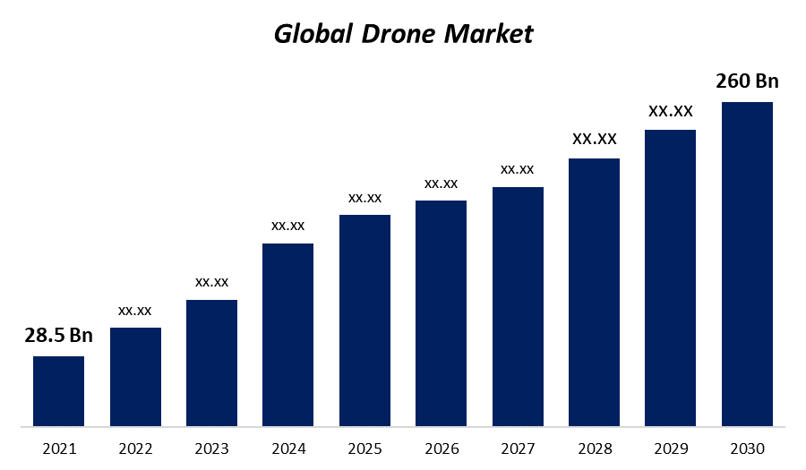
(F) Current status of Project
- Currently, X-CAM is in a conceptual stage, but we are actively moving towards making it a reality. We are actively studying drone technology and building concepts for Charging Pads. We are seeking guidance from our professors and our mentor, to build the concepts more solid and robust. Basic outlook of the drone and charging system is nearly ready, and we are taking external professional services to design the 2D outlook in AutoCAD.
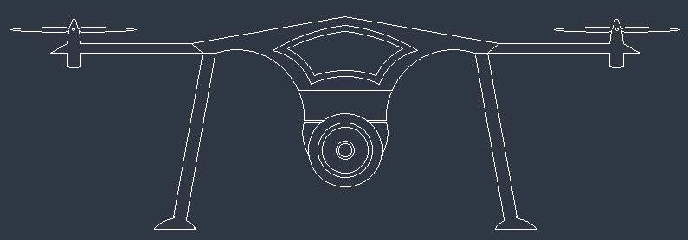

- One core concept in X-CAM is Arduino programming with python integration. To strengthen our capabilities in arduino programming, we have attended an arduino workshop and started practicing it by making several smaller ideas. To understand Python, we have started learning the Python language on our own, by referring to multiple books and online videos, and seeking guidance from professors whenever necessary.
- For improving battery life and charging duration, we are also trying to build a custom battery pack with some smart charging tech, which would take X-CAM to a whole new level.
Looking at our progress, it is safe to say we are approaching closer to start developing a prototype
- Currently our project targets on building a basic model of X-CAM which comprises live feed and basic auto surveillance with charging pad technology. It will surveil a definite area which is pre programmed, and will retrieve to the nearest charging pad when battery is low. This will require a minimum of 6 months.
.
(G) Future Proposition of Project
- Next Stage of X-CAM will be a massive upgrade to the system. It is named X-TRACK (Tactical Reconnaissance by Autonomous Controlled Kopter).
- X-CAM will be integrated with Artificial Intelligence (AI) technologies to identify the target by facial recognition, target locking and auto chase, upgrading cameras for thermal and night vision, live feed on mobile application and much more.
- It would be built to withstand the toughest of environments, whether it's flying at high altitudes , in severe cold, windy conditions, or wet weather for military applications.
(H) Breakup of Fund Required in ₹
Consumables | Rs 35,000/-
Miscellaneous expenses | Rs 5,000/-
Professional services | Rs 5,000/-
Patent filing
TOTAL | Rs 45,000/-

 | Total Amount | ₹ 45,000/-
I | References: | - Drone Surveillance Market  - The Arduino auto-level quadcopter

